kesara

* Reading images as gray scale and in range 0-255
* Len dataset: 202
* 0.1 for test, don't shuffle
* Aug1 + Aug2 then random shuffle
* Len train dataset: 543
* Sample :
* 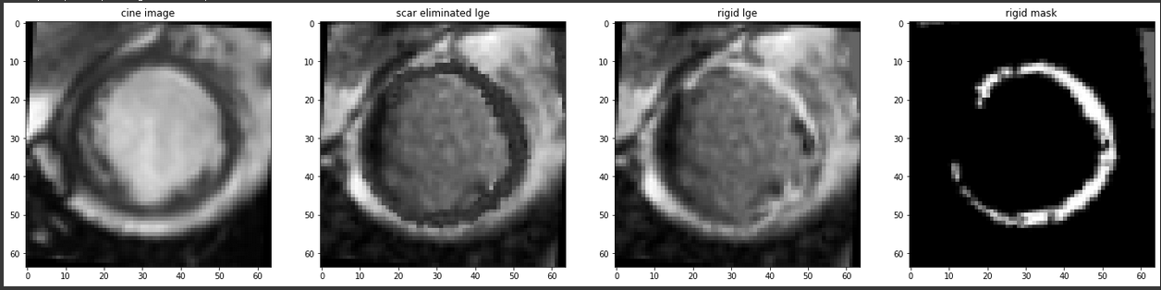
* Batch size = 1
* Lambda = 0.1
* Lr = 1e-3
* 300 epoch , 299 -0.7604431933131666



